**Week 4 – Database Development and Class Registration**

Adam E. Svatek

The University of Arizona Global Campus

CST499: Capstone for Computer Software Technology (CSF2415A)

Professor Joseph Rangitsch

May 13, 2024

**Create Tables within the MySQL Database Related to the Rest of My Design**

Last week, I created the sole table titled “students” in my SQL database. This week, I created three more tables, as shown in Figure 1. The “courses” table has the primary key of “courseID" which will be the same as the course number for UAGC courses, such as CST499 for this course. This table also contains the course name and the maximum number of students that can enroll in a single class. “courseOffering” is a table where the primary key, “offeringID” is tied to each instance of the course that is taken. In the case of this class, I will use the 8-character code “CSF2415A,” which will be tied to one specific offering of this course. The “courseEnrollment” table has a primary key for “enrollmentID” and the “studentID” and “offeringID” attached to it. If a class is at its maximum capacity, but a student wishes to be placed on a waiting list, their information would be added to the “queue” table. If a spot opens up for the class, the “courseOpenNotification” table is used to notify a student that a spot is open for them in the instance of the class that they wish to take.

One lesson that I have learned in creating these tables is to use snake case rather than camel case. As you can see in Figure 1, SQL is not case-sensitive. Each one of the tables is shown in lowercase here. Snake case would add clarity.

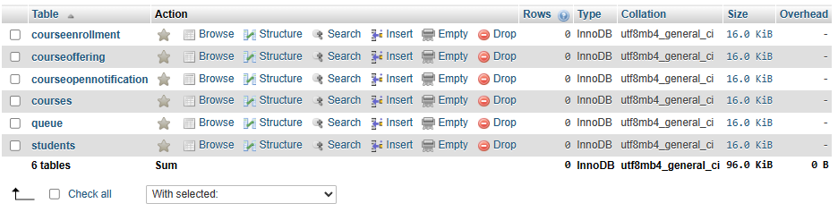

**Figure 1: Database Tables**

Next, I created an SQL table relationship diagram before adding the foreign keys. I took a screenshot, pasted it into Microsoft Paint, and drew lines where foreign keys would apply, see Figure 2. While creating the foreign keys, I found that I had used int(8) instead of varchar(8) for the offering ID in the queue and course open notification tables. I went back and corrected this as seen in Figure 3.

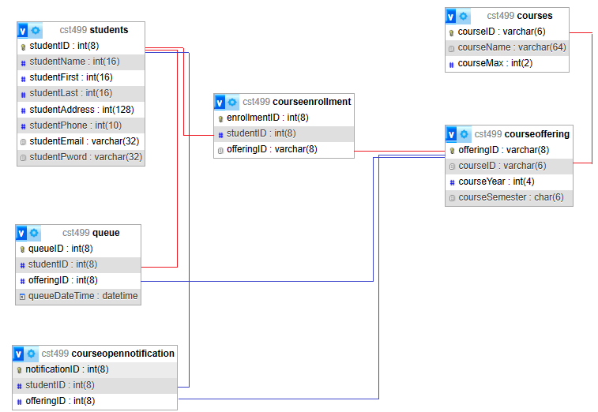

**Figure 2: SQL Table Relationship Diagram Draft**

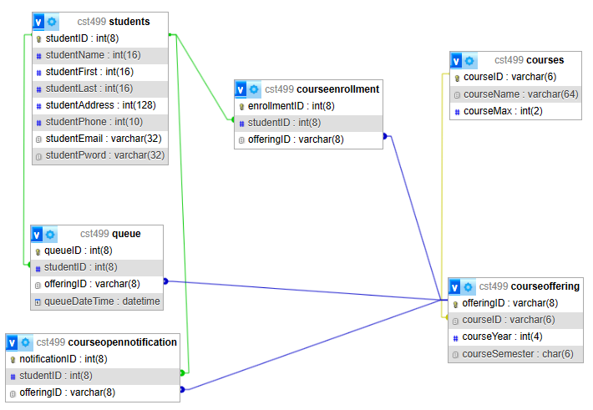

**Figure 3: SQL Table Relationship Diagram**

**Create the different pages related to the design per work in Week 1 and Week 2**

These pages have not been created yet, but will be similar to those in the format of Figures 3 and 4.

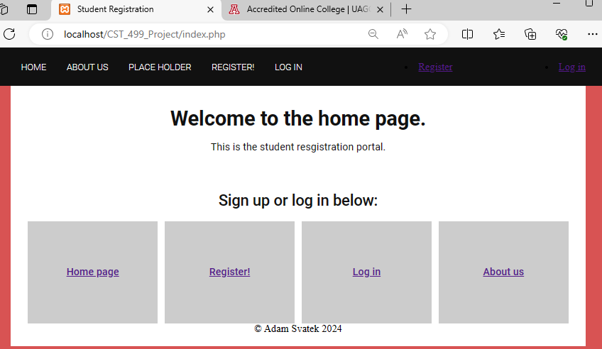

**Figure 4: Landing Page**

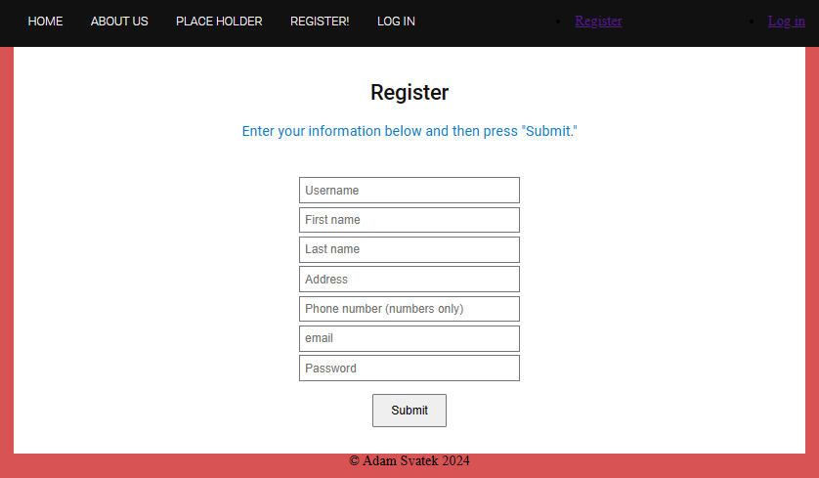

**Figure 5: Registration Page**

**Generate screenshots of the database and the tables created**

I created a list of classes by courseID, courseName, and courseMax in an Excel spreadsheet to populate courses for my database (Figure 6). From this, I created the code to enter all 21 of these courses to the “courses” table of my database (Figure 7). They have been populated correctly, as seen in Figure 8. I have also added three students to “students” (Figure 9).

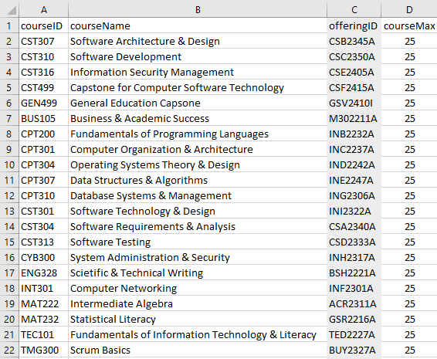

**Figure 6: Course to be added to “courses” table**

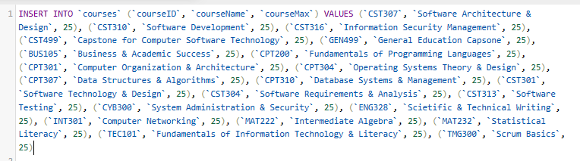

**Figure 7: SQL code to add courses to “courses” table**

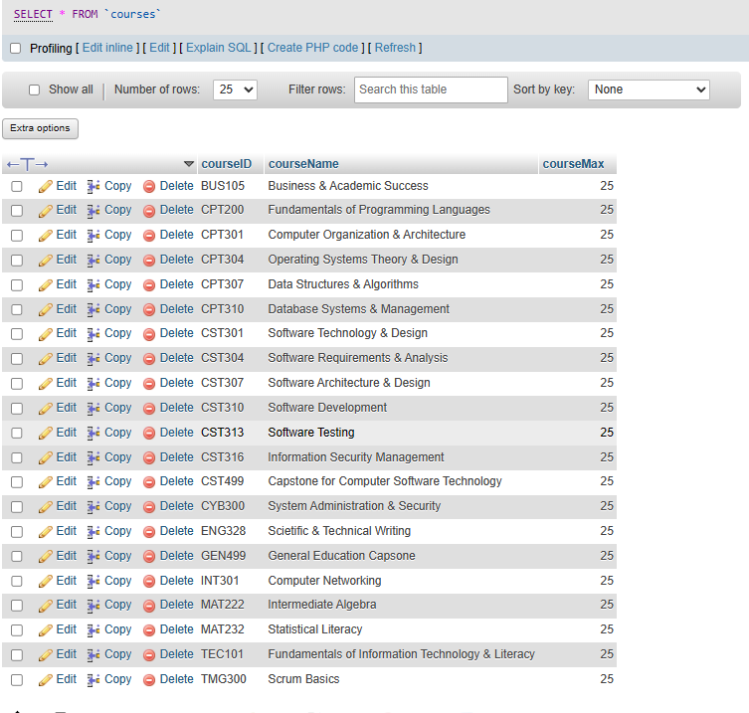

**Figure 8: “courses” table populated**

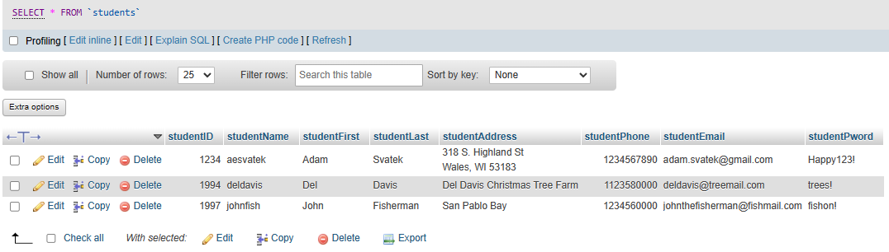

**Figure 9: 3 students populated into “students” table**

**Screenshot of pages developed**

These pages are currently under construction and will look similar to the one below.

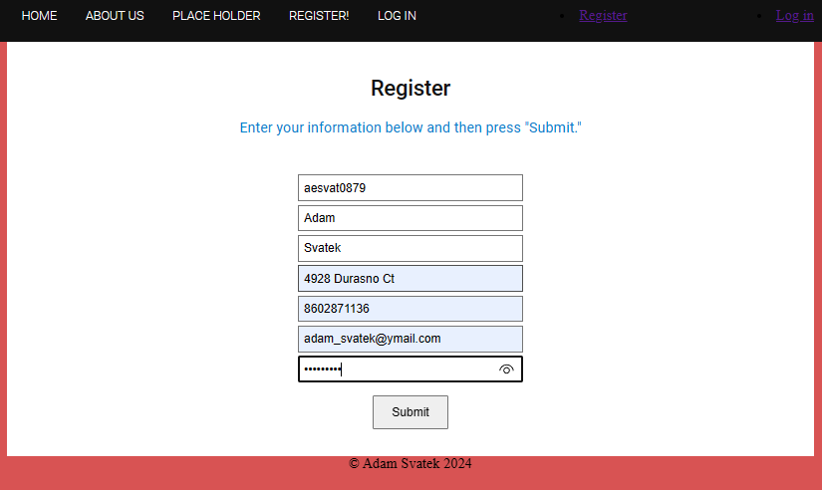

**Figure 10: Registration Page Layout**

**PHP Code and Experiences Through Implementation Phase**

I created some code to submit the student’s information to the webpage (Figure 11). I have run into issues getting the information to populate my database and the database information to populate my web page. I have learned some valuable coding lessons from a series of YouTube videos, “PHP for Beginners” (Krossing, 2023). I will continue learning PHP for this course and hope to get many of the functions of this website to work properly.

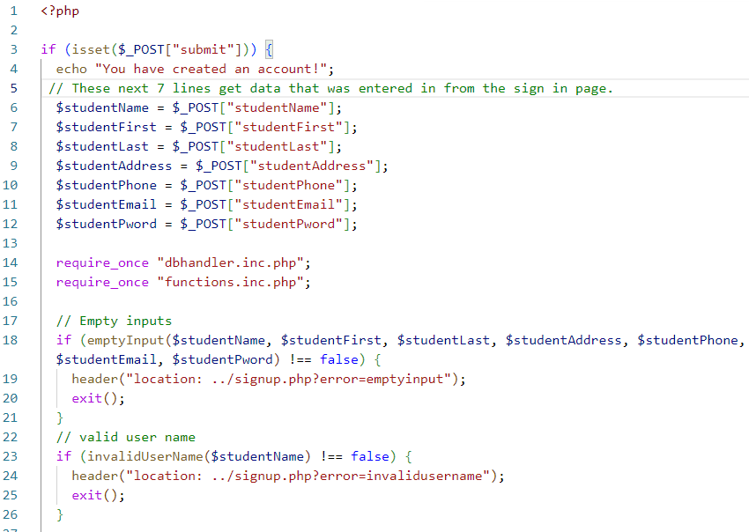

**Figure 11: PHP code to submit information to the database**

**References**

Connolly, R., & Hoar, R. (2018). Fundamentals of web development (2nd ed.). Pearson.

Krossing, D. (2023, August 31). PHP Course for Beginners. YouTube. https://www.youtube.com/playlist?list=PL0eyrZgxdwhwwQQZA79OzYwl5ewA7HQih

Sommerville, I. (2016). Software Engineering (10th ed.). Pearson.